**Mandatory Exercise 4 – Advanced JavaScript with React – Chat app Writeup**

1. **Project install**

TRUPTI@LAPTOP-RLRGMMNC MINGW64 /e/frontwebutvecklare/projects

npx -i install create-react-app mandatory-advanced-js1

cd mandatory-advanced-js1/

git init

git commit -m "Initial setup"

git remote add origin git@github.com:truptigaonkar/mandatory-advanced-js1.git

git push -u origin master

1. **Authentication login**

**App.js**

import React, { Component } from 'react';

import './App.css';

// Component Authentication

class LoginForm extends React.Component {

handleonSubmit(e) {

e.preventDefault()

let username = this.refs.username.value

this.props.onSignIn(username)

}

// Rendering login page

render() {

return (

<form onSubmit={this.handleonSubmit.bind(this)}>

<h3>Sign in</h3>

<input type="text" ref="username" required="required" minLength={1} maxLength={12} placeholder="Enter USERNAME" />

<input type="submit" value="Login" />

</form>

)

}

}

class App extends Component {

constructor(props) {

super(props)

this.state = {

user: null

}

}

// Signin with authenticated user

signIn(username) {

// calling setState will re-render the entire app efficiently.

this.setState({ user: {username} })

}

// Authentication signout which clear out user from state

signOut() {

this.setState({ user: null })

}

// Rendering page after successfully login

render() {

return (

<div className="App">

<h1>Chat App</h1>

{

(this.state.user) ?

<Welcome user={this.state.user} onSignOut={this.signOut.bind(this)} />

:

<LoginForm onSignIn={this.signIn.bind(this)} />

}

</div>

);

}

}

// Component to add Username and signout button to page

const Welcome = ({ user, onSignOut }) => {

return (

<div>

Welcome <strong>{user.username}</strong>! <br />

<a href="javascript:;" onClick={onSignOut}>Sign out</a>

</div>

)

}

export default App;

1. **Listing messages by connecting to backend server Socket.io**

**Install socket.io client:**

PS E:\frontwebutvecklare\projects\mandatory-advanced-js1> npm install socket.io-client

npm WARN ts-pnp@1.0.1 requires a peer of typescript@* but none is installed. You must install peer dependencies yourself.

npm WARN optional SKIPPING OPTIONAL DEPENDENCY: fsevents@1.2.7 (node_modules\chokidar\node_modules\fsevents):

npm WARN notsup SKIPPING OPTIONAL DEPENDENCY: Unsupported platform for fsevents@1.2.7: wanted {"os":"darwin","arch":"any"} (current: {"os":"win32","arch":"x64"})

npm WARN optional SKIPPING OPTIONAL DEPENDENCY: fsevents@1.2.4 (node_modules\fsevents):

npm WARN notsup SKIPPING OPTIONAL DEPENDENCY: Unsupported platform for fsevents@1.2.4: wanted {"os":"darwin","arch":"any"} (current: {"os":"win32","arch":"x64"})

+ socket.io-client@2.2.0

added 30 packages from 21 contributors and audited 36278 packages in 21.006s

found 63 low severity vulnerabilities

run `npm audit fix` to fix them, or `npm audit` for details

PS E:\frontwebutvecklare\projects\mandatory-advanced-js1>

1. **React with Reactstrap**

<https://reactstrap.github.io/>

Adding Bootstrap

1. Install reactstrap and Bootstrap from NPM. Reactstrap does not include Bootstrap CSS so this needs to be installed as well:

npm install bootstrap --save

npm install --save reactstrap react react-dom

1. Import Bootstrap CSS in the src/index.js file:

import 'bootstrap/dist/css/bootstrap.min.css';

1. Import required reactstrap components within src/App.js file or your custom component files:

import { Button } from 'reactstrap';

1. Now you are ready to use the imported reactstrap components within your component hierarchy defined in the render method. Here is an example [App.js](https://gist.github.com/Thomas-Smyth/006fd507a7295f17a8473451938f9935) redone using reactstrap.
2. Import the components you need

Danger!

import React from 'react';

import { Button } from 'reactstrap';

export default (props) => {

return (

<Button color="danger">Danger!</Button>

);

};

1. Get all the components

Reactstrap components:

<https://reactstrap.github.io/components/navbar/>

React + Bootstrap component

<https://react-bootstrap.github.io/components/alerts/>

1. **Font awesome**

<https://stackoverflow.com/questions/23116591/how-to-include-a-font-awesome-icon-in-reacts-render>

f you are **new to React JS** and using **create-react-app cli** command to create the application, then run the following NPM command to include the latest version of font-awesome.

npm install --save font-awesome

import font-awesome to your index.js file. Just add below line to your index.js file

import '../node_modules/font-awesome/css/font-awesome.min.css';

or

import 'font-awesome/css/font-awesome.min.css';

Don't forget to use **className** as attribute

render: function() {

return <div><i className="fa fa-spinner fa-spin">no spinner but why</i></div>;

}

1. **Emoj and link:** <https://emojipedia.org/>

npm install react-linkify --save

npm install **--**save react**-**emojione

import Linkify from "react-linkify";

import Emojify from "react-emojione";

<Linkify>

<Emojify style={{height: 20, width: 20}}>{objItem.content}</Emojify>

</Linkify>

1. **Deploying on github server:**

<https://reactgo.com/deploy-react-app-github-pages/>

### **1. Add homepage**

**package.json**

{

"homepage": "https://truptigaonkar.github.io/mandatory-advanced-js1",

"name": "mandatory-advanced-js1",

"version": "0.1.0",

"private": true,

"dependencies": {

"bootstrap": "^4.3.1",

"font-awesome": "^4.7.0",

"gh-pages": "^2.0.1",

"react": "^16.8.3",

"react-custom-scroll": "^4.0.1",

"react-dom": "^16.8.3",

"react-emojione": "^5.0.1",

"react-linkify": "^0.2.2",

"react-scripts": "2.1.5",

"react-scrollbar": "^0.5.4",

"reactstrap": "^7.1.0",

"socket.io-client": "^2.2.0"

},

"scripts": {

"start": "react-scripts start",

"build": "react-scripts build",

"test": "react-scripts test",

"eject": "react-scripts eject"

},

"eslintConfig": {

"extends": "react-app"

},

"browserslist": [

">0.2%",

"not dead",

"not ie <= 11",

"not op_mini all"

]

}

### **2. Install gh-pages**

PS E:\frontwebutvecklare\projects\mandatory-advanced-js1> npm install --save gh-pages

### **3. Deploy script**

**package.json**

{

"homepage": "https://truptigaonkar.github.io/mandatory-advanced-js1",

"name": "mandatory-advanced-js1",

"version": "0.1.0",

"private": true,

"dependencies": {

"bootstrap": "^4.3.1",

"font-awesome": "^4.7.0",

"gh-pages": "^2.0.1",

"react": "^16.8.3",

"react-custom-scroll": "^4.0.1",

"react-dom": "^16.8.3",

"react-emojione": "^5.0.1",

"react-linkify": "^0.2.2",

"react-scripts": "2.1.5",

"react-scrollbar": "^0.5.4",

"reactstrap": "^7.1.0",

"socket.io-client": "^2.2.0"

},

"scripts": {

"predeploy": "npm run build",

"deploy": "gh-pages -d build",

"start": "react-scripts start",

"build": "react-scripts build",

"test": "react-scripts test",

"eject": "react-scripts eject"

},

"eslintConfig": {

"extends": "react-app"

},

"browserslist": [

">0.2%",

"not dead",

"not ie <= 11",

"not op_mini all"

]

}

### **4. Setup source to gh-pages branch.**

Go to your repository -> Settings

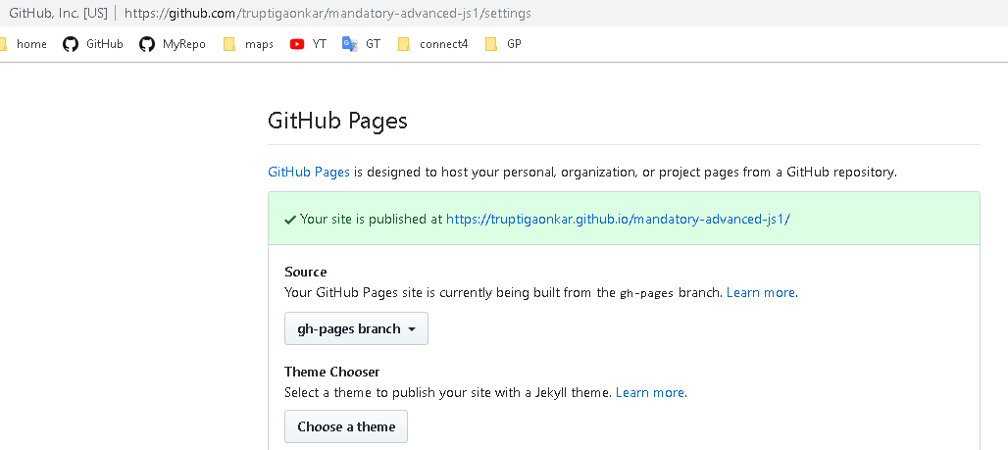

Click on given url to see your webpage <https://truptigaonkar.github.io/mandatory-advanced-js1/>